MATLAB Code for Plotting

clear;clc;

fn = @(x) (-1 * (sin(x) + 0.05*x^2 + 1));

z = 10;

x_int = [-7 7]

%Iteration 1

fplot(fn, x_int)

title('Function from [-7, 7]')

xlabel('x');

ylabel('y');

hold on

% % (All data imported from Python script) Iter 5

% y = [-0.11229277260835424, -0.11229277260835424, -0.11229277260835424, -0.11229277260835424, -0.11229277260835424, -0.11229277260835424, -2.1342968466406536, -2.0273573138112457, -1.1709451736338776, -0.6783608587594028]

% x = [-1.4444444444444446, -1.4444444444444446, -1.4444444444444446, -1.4444444444444446, -1.4444444444444446, -1.4444444444444446, 1.666666666666666, 5.666666666666666, 3.666666666666666, -0.3333333333333339]

% Iter 4

% x = [-0.3333333333333339, -0.3333333333333339, -0.3333333333333339, -0.3333333333333339, -5.0, 6.333333333333332, 1.666666666666666, 4.111111111111111, 4.111111111111111, -0.3333333333333339]

% y = [-0.6783608587594028, -0.6783608587594028, -0.6783608587594028, -0.6783608587594028, -3.2089242746631386, -3.0556825654377264, -2.1342968466406536, -1.0204483264220747, -1.0204483264220747, -0.6783608587594028]

% Iter 3

% x = [-0.3333333333333339, -0.3333333333333339, -0.3333333333333339, -0.3333333333333339, -0.3333333333333339, 6.333333333333332, 1.666666666666666, -3.0, 5.0, -2.7777777777777777]

% y = [-0.6783608587594028, -0.6783608587594028, -0.6783608587594028, -0.6783608587594028, -0.6783608587594028, -3.0556825654377264, -2.1342968466406536, -1.3088799919401328, -1.2910757253368614, -1.0299604777347366]

% Iter 2

% x = [-0.3333333333333339, -0.3333333333333339, -0.3333333333333339, -0.3333333333333339, 6.333333333333332, 2.333333333333332, 5.444444444444443, 5.222222222222221, -3.0, -2.7777777777777777]

% y = [-0.6783608587594028, -0.6783608587594028, -0.6783608587594028, -0.6783608587594028, -3.0556825654377264, -1.9953081039605474, -1.7382966628445353, -1.4907543438623208, -1.3088799919401328, -1.0299604777347366]

% Iter 1

x = [-0.5555555555555562, -0.3333333333333339, -2.7777777777777777, 3.666666666666666, -3.2222222222222223, 2.333333333333332, 5.666666666666666, -5.222222222222222, 6.555555555555555, 7.0]

y = [-0.4880167129935661, -0.6783608587594028, -1.0299604777347366, -1.1709451736338776, -1.5996780356465323, -1.9953081039605474, -2.0273573138112457, -3.236406149964839, -3.4177804937919745, -4.106986598718789]

scatter(x,y)

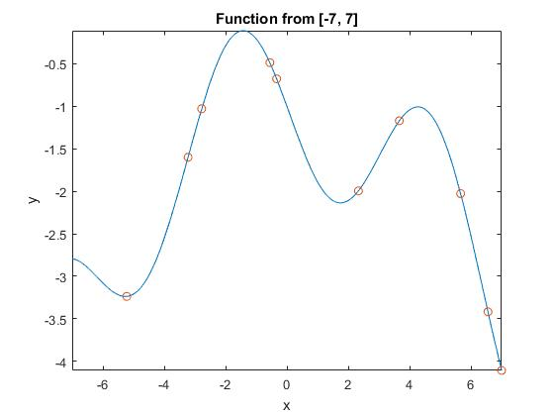IT_1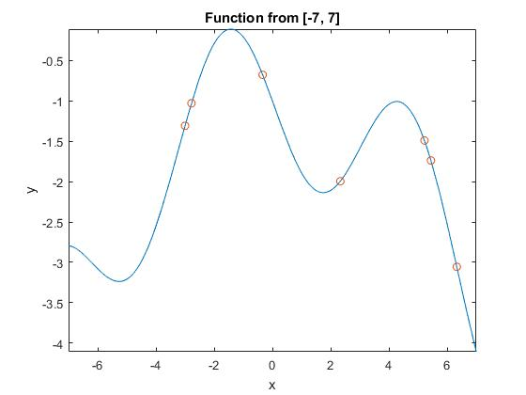IT_2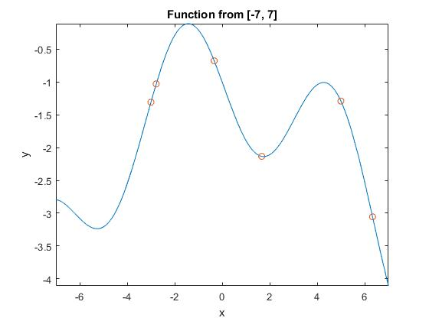IT_3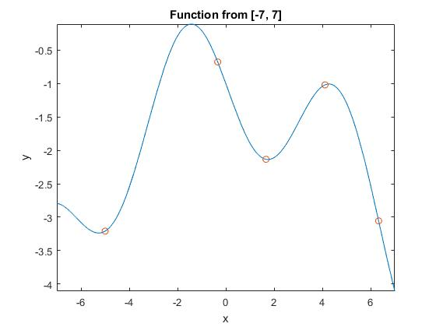IT_4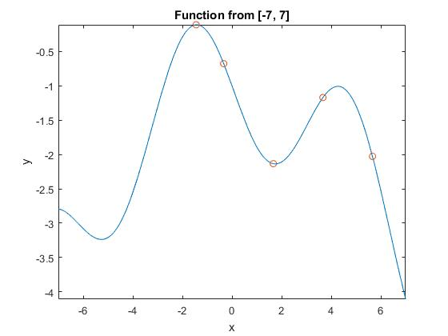IT_5

1. Population (binary and decimal forms) included in executed code below. Includes ranked lists according to fitness as well.
2. Mating pool generation (roulette wheel) detailed in executed code for each iteration
3. Method of obtaining new generation also detailed in executed code. Generally, in each generation, the fitness values for each design were calculated. Taking and keeping the two highest designs while using Roulette wheel to decide if the remaining 8 are kept or not (if not kept, replace with elite), I then use probabilities to determine whether crossover and/or mutation occurs in the 8 designs. The 2 elites, plus the 8 designs, are combined into a new generation; fitness values are recalculated, new elites are determined, and the cycle repeats for 5 total iterations.
4. The results of my GA implementation are pretty accurate, seeing as with each iteration, the solution improves. The GA method is quicker because it is able to get a generally accurate solution within 5 iteration (although random each time), while the gradient-based method involved lots of guess and check due to guessing the initial starting value, which it depends on greatly. When comparing with classmates, it seems that my implementation is more scattered by the 5th iteration. In implementations that did not use Roulette wheel to vet out weak designs, the results are comparably less scattered than mine, but also less accurate. Those that had the fittest values initially in their first generation ended with the least widely distributed solutions.

Python Code – Execution

Python 3.5.3 (v3.5.3:1880cb95a742, Jan 16 2017, 16:02:32) [MSC v.1900 64 bit (AMD64)] on win32

Type "copyright", "credits" or "license()" for more information.

>>>

RESTART: C:\Users\Eley\Documents\ME 379 Comp Methods Optimization\HW2\genetic-algo\genetic-algo2.py

ELEY NG, HW2: GA Implementation

size interval 0.222222222222222

pop_lst_bin ['000000', '000001', '000010', '000011', '000100', '000101', '000110', '000111', '001000', '001001', '001010', '001011', '001100', '001101', '001110', '001111', '010000', '010001', '010010', '010011', '010100', '010101', '010110', '010111', '011000', '011001', '011010', '011011', '011100', '011101', '011110', '011111', '100000', '100001', '100010', '100011', '100100', '100101', '100110', '100111', '101000', '101001', '101010', '101011', '101100', '101101', '101110', '101111', '110000', '110001', '110010', '110011', '110100', '110101', '110110', '110111', '111000', '111001', '111010', '111011', '111100', '111101', '111110', '111111']

pop_lst [-7.0, -6.777777777777778, -6.555555555555555, -6.333333333333333, -6.111111111111111, -5.888888888888889, -5.666666666666667, -5.444444444444445, -5.222222222222222, -5.0, -4.777777777777778, -4.555555555555555, -4.333333333333334, -4.111111111111111, -3.8888888888888893, -3.666666666666667, -3.4444444444444446, -3.2222222222222223, -3.0, -2.7777777777777777, -2.5555555555555554, -2.333333333333334, -2.1111111111111116, -1.8888888888888893, -1.666666666666667, -1.4444444444444446, -1.2222222222222223, -1.0, -0.7777777777777786, -0.5555555555555562, -0.3333333333333339, -0.1111111111111116, 0.11111111111111072, 0.33333333333333304, 0.5555555555555554, 0.7777777777777777, 1.0, 1.2222222222222214, 1.4444444444444446, 1.666666666666666, 1.8888888888888893, 2.1111111111111107, 2.333333333333332, 2.5555555555555554, 2.777777777777777, 3.0, 3.2222222222222214, 3.4444444444444446, 3.666666666666666, 3.8888888888888875, 4.111111111111111, 4.333333333333332, 4.555555555555555, 4.777777777777777, 5.0, 5.222222222222221, 5.444444444444443, 5.666666666666666, 5.8888888888888875, 6.111111111111111, 6.333333333333332, 6.555555555555555, 6.777777777777777, 7.0]

pop_d {-0.7734794835010813: '010100', -0.5491363404838981: '010101', -0.6783608587594028: '011110', -1.591120008059867: '101101', -2.1734992708105674: '001111', -3.025381147039765: '001011', -4.106986598718789: '111111', -0.1348306638830009: '011010', -0.32854903743351116: '011100', -2.955428545673383: '000011', -2.4358307958989194: '001110', -1.1434951104802444: '110101', -1.0204483264220747: '110010', -0.4880167129935661: '011101', -1.8914532976851195: '010000', -1.43859356929174: '101110', -1.7382966628445353: '111000', -0.20852901519210354: '011011', -1.8914709848078965: '100100', -2.0803863030979444: '101001', -3.038510230331518: '000100', -1.1709451736338776: '110000', -3.118109307400079: '000101', -3.236406149964839: '001000', -2.69605767090305: '111011', -1.3327502523517074: '100001', -3.4177804937919745: '111101', -3.1837537972998646: '000110', -2.8222405815346447: '000001', -2.0145520521663816: '100101', -3.0556825654377264: '111100', -3.2259008680196604: '000111', -2.6696751303680486: '001101', -0.36529270924773527: '010110', -2.3497919271678205: '111010', -1.5996780356465323: '010001', -1.9953081039605474: '101010', -1.7416444605368686: '101100', -1.2949664554013007: '101111', -2.793013401281211: '000000', -1.1114999124605698: '100000', -1.0299604777347366: '010011', -0.143480931137124: '011000', -1.8796069362520051: '101011', -2.0963492027002877: '100110', -1.0098743876181269: '110011', -1.4907543438623208: '110111', -0.11229277260835424: '011001', -1.0765148831134272: '110001', -1.3088799919401328: '010010', -2.879750370405556: '000010', -2.1342968466406536: '100111', -3.771586578959181: '111110', -1.0499274949355435: '110100', -0.22856135463839278: '010111', -3.1392209389024712: '001010', -1.2910757253368614: '110110', -2.8679033901596513: '001100', -2.0273573138112457: '111001', -1.5428474845372975: '100010', -0.8897346554406638: '011111', -3.2089242746631386: '001001', -2.1282287688183974: '101000', -1.731944789726982: '100011'}

length of pop_lst_bin 64

Gen 1: binary random initial pop rand_lst_bin ['010001', '010011', '111001', '110000', '011101', '111111', '111101', '001000', '011110', '101010']

Gen 1: random initial pop [-3.2222222222222223, -2.7777777777777777, 5.666666666666666, 3.666666666666666, -0.5555555555555562, 7.0, 6.555555555555555, -5.222222222222222, -0.3333333333333339, 2.333333333333332]

fitness val [-1.5996780356465323, -1.0299604777347366, -2.0273573138112457, -1.1709451736338776, -0.4880167129935661, -4.106986598718789, -3.4177804937919745, -3.236406149964839, -0.6783608587594028, -1.9953081039605474]

Gen 1: min to max sorted list of fn [-4.106986598718789, -3.4177804937919745, -3.236406149964839, -2.0273573138112457, -1.9953081039605474, -1.5996780356465323, -1.1709451736338776, -1.0299604777347366, -0.6783608587594028, -0.4880167129935661]

Gen 1: Y Values [-0.4880167129935661, -0.6783608587594028, -1.0299604777347366, -1.1709451736338776, -1.5996780356465323, -1.9953081039605474, -2.0273573138112457, -3.236406149964839, -3.4177804937919745, -4.106986598718789]

Gen 1: X Values (binary) ['011101', '011110', '010011', '110000', '010001', '101010', '111001', '001000', '111101', '111111']

Gen 1: X Values (dec) [-0.5555555555555562, -0.3333333333333339, -2.7777777777777777, 3.666666666666666, -3.2222222222222223, 2.333333333333332, 5.666666666666666, -5.222222222222222, 6.555555555555555, 7.0]

elites cand ['011101', '011110']

MATING POOL generation

Candidate Design 1

r 0.7280125542577602

low (0.0) is lower than r = 0.7280125542577602 and high (0.0) is higher than r --> ACCEPT

Candidate Design 2

r 0.3018993258434338

low (0.03232815653007159) is lower than r = 0.3018993258434338 and high (0.03232815653007159) is higher than r --> ACCEPT

Candidate Design 3

r 0.013718910324528322

REJECT candidate and replace with elite

Candidate Design 4

r 0.5189393326928514

low (0.17071178572975376) is lower than r = 0.5189393326928514 and high (0.17071178572975376) is higher than r --> ACCEPT

Candidate Design 5

r 0.5274967687254057

low (0.2697629584221075) is lower than r = 0.5274967687254057 and high (0.2697629584221075) is higher than r --> ACCEPT

Candidate Design 6

r 0.3632464657327231

REJECT candidate and replace with elite

Candidate Design 7

r 0.39597657268170694

REJECT candidate and replace with elite

Candidate Design 8

r 0.9237844726438312

low (0.6694228723177469) is lower than r = 0.9237844726438312 and high (0.6694228723177469) is higher than r --> ACCEPT

Candidate Design 9

r 0.4171974722900149

REJECT candidate and replace with elite

Candidate Design 10

r 0.17072970916234065

REJECT candidate and replace with elite

ORD_LST [-0.4880167129935661, -0.4880167129935661, -0.4880167129935661, -0.4880167129935661, -0.4880167129935661, -4.106986598718789, -3.4177804937919745, -2.0273573138112457, -1.9953081039605474, -1.0299604777347366]

elites cand ['010001', '010011']

Gen 1: Ranked Candidates ['010001', '010011', '111001', '110000', '011101', '111111', '111101', '001000', '011110', '101010']

Crossover & mutation ['111001', '110000', '011101', '111111', '111101', '001000', '011110', '101010']

crossover!!!

New Child #1 111000 New Child #2 111000

crossover!!!

New Child #1 011111 New Child #2 110111

crossover!!!

New Child #1 111100 New Child #2 010010

crossover!!!

New Child #1 011110 New Child #2 101010

Gen 2 Candidates ['010001', '010011', '111000', '111000', '011111', '110111', '111100', '010010', '011110', '101010']

Gen 2 Evaluated for fitness [-1.5996780356465323, -1.0299604777347366, -1.7382966628445353, -1.7382966628445353, -0.8897346554406638, -1.4907543438623208, -3.0556825654377264, -1.3088799919401328, -0.6783608587594028, -1.9953081039605474]

resorted list [-3.0556825654377264, -1.9953081039605474, -1.7382966628445353, -1.7382966628445353, -1.5996780356465323, -1.4907543438623208, -1.3088799919401328, -1.0299604777347366, -0.8897346554406638, -0.6783608587594028]

max -0.6783608587594028

MATING POOL generation

Candidate Design 1

r 0.5103708920424009

low (0.041155121859532184) is lower than r = 0.5103708920424009 and high (0.041155121859532184) is higher than r --> ACCEPT

Candidate Design 2

r 0.6883401479352251

low (0.12382044324015967) is lower than r = 0.6883401479352251 and high (0.12382044324015967) is higher than r --> ACCEPT

Candidate Design 3

r 0.04053706283209413

REJECT candidate and replace with elite

Candidate Design 4

r 0.8079155414500516

low (0.30927340427201455) is lower than r = 0.8079155414500516 and high (0.30927340427201455) is higher than r --> ACCEPT

Candidate Design 5

r 0.16705727380634527

REJECT candidate and replace with elite

Candidate Design 6

r 0.7453002211860958

low (0.5098433060691774) is lower than r = 0.7453002211860958 and high (0.5098433060691774) is higher than r --> ACCEPT

Candidate Design 7

r 0.8322036982894847

low (0.6193800478036695) is lower than r = 0.8322036982894847 and high (0.6193800478036695) is higher than r --> ACCEPT

Candidate Design 8

r 0.9268475472367219

low (0.7398355782355658) is lower than r = 0.9268475472367219 and high (0.7398355782355658) is higher than r --> ACCEPT

Candidate Design 9

r 0.21588142845554592

REJECT candidate and replace with elite

Candidate Design 10

r 0.38157010769560606

REJECT candidate and replace with elite

Gen 2 Y Values (dec) [-0.6783608587594028, -0.6783608587594028, -0.6783608587594028, -0.6783608587594028, -3.0556825654377264, -1.9953081039605474, -1.7382966628445353, -1.4907543438623208, -1.3088799919401328, -1.0299604777347366]

Gen 2: X Value Candidates (bin) ['011110', '011110', '011110', '011110', '111100', '101010', '111000', '110111', '010010', '010011']

Gen 2: X Value (dec) [-0.3333333333333339, -0.3333333333333339, -0.3333333333333339, -0.3333333333333339, 6.333333333333332, 2.333333333333332, 5.444444444444443, 5.222222222222221, -3.0, -2.7777777777777777]

elites cand ['011110', '011110']

Gen 2: RANKED X Values (bin) ['011110', '011110', '011110', '011110', '010011', '010010', '110111', '111000', '101010', '111100']

Gen 2: RANKED X Values (dec) [-0.3333333333333339, -0.3333333333333339, -0.3333333333333339, -0.3333333333333339, -2.7777777777777777, -3.0, 5.222222222222221, 5.444444444444443, 2.333333333333332, 6.333333333333332]

Crossover & mutation ['011110', '011110', '010011', '010010', '110111', '111000', '101010', '111100']

crossover!!!

New Child #1 011110 New Child #2 100111

mutate!!!

No crossover: Parents = Children

crossover!!!

New Child #1 110110 New Child #2 111100

mutate!!!

No crossover: Parents = Children

mutate!!!

Gen 3 Candidates ['011110', '011110', '011110', '100111', '010011', '010010', '110110', '111100', '101010', '111100']

Gen 3 Evaluated for fitness [-0.6783608587594028, -0.6783608587594028, -0.6783608587594028, -2.1342968466406536, -1.0299604777347366, -1.3088799919401328, -1.2910757253368614, -3.0556825654377264, -1.9953081039605474, -3.0556825654377264]

resorted list [-3.0556825654377264, -3.0556825654377264, -2.1342968466406536, -1.9953081039605474, -1.3088799919401328, -1.2910757253368614, -1.0299604777347366, -0.6783608587594028, -0.6783608587594028, -0.6783608587594028]

max -0.6783608587594028

MATING POOL generation

Candidate Design 1

r 0.03077089607852257

REJECT candidate and replace with elite

Candidate Design 2

r 0.690366933393245

low (0.08355653559265275) is lower than r = 0.690366933393245 and high (0.08355653559265275) is higher than r --> ACCEPT

Candidate Design 3

r 0.8962000912939537

low (0.16195018589015475) is lower than r = 0.8962000912939537 and high (0.16195018589015475) is higher than r --> ACCEPT

Candidate Design 4

r 0.05990694640251182

REJECT candidate and replace with elite

Candidate Design 5

r 0.508077208846644

low (0.35706245627139394) is lower than r = 0.508077208846644 and high (0.35706245627139394) is higher than r --> ACCEPT

Candidate Design 6

r 0.7195645608553327

low (0.4689652691918174) is lower than r = 0.7195645608553327 and high (0.4689652691918174) is higher than r --> ACCEPT

Candidate Design 7

r 0.9639657714869767

low (0.5912446643326852) is lower than r = 0.9639657714869767 and high (0.5912446643326852) is higher than r --> ACCEPT

Candidate Design 8

r 0.45663686217376065

REJECT candidate and replace with elite

Candidate Design 9

r 0.6239243587591601

REJECT candidate and replace with elite

Candidate Design 10

r 0.686753395723289

REJECT candidate and replace with elite

Gen 3 Y Values (dec) [-0.6783608587594028, -0.6783608587594028, -0.6783608587594028, -0.6783608587594028, -0.6783608587594028, -3.0556825654377264, -2.1342968466406536, -1.3088799919401328, -1.2910757253368614, -1.0299604777347366]

Gen 3: X Value Candidates (bin) ['011110', '011110', '011110', '011110', '011110', '111100', '100111', '010010', '110110', '010011']

Gen 3: X Value (dec) [-0.3333333333333339, -0.3333333333333339, -0.3333333333333339, -0.3333333333333339, -0.3333333333333339, 6.333333333333332, 1.666666666666666, -3.0, 5.0, -2.7777777777777777]

elites cand ['011110', '011110']

Gen 3: RANKED X Values (bin) ['011110', '011110', '011110', '011110', '011110', '010011', '110110', '010010', '100111', '111100']

Gen 3: RANKED X Values (dec) [-0.3333333333333339, -0.3333333333333339, -0.3333333333333339, -0.3333333333333339, -0.3333333333333339, -2.7777777777777777, 5.0, -3.0, 1.666666666666666, 6.333333333333332]

Crossover & mutation ['011110', '011110', '011110', '010011', '110110', '010010', '100111', '111100']

crossover!!!

New Child #1 011110 New Child #2 100111

crossover!!!

New Child #1 011111 New Child #2 001001

crossover!!!

New Child #1 110010 New Child #2 110010

No crossover: Parents = Children

Gen 4 Candidates ['011110', '011110', '011110', '100111', '011111', '001001', '110010', '110010', '100111', '111100']

Gen 4 Evaluated for fitness [-0.6783608587594028, -0.6783608587594028, -0.6783608587594028, -2.1342968466406536, -0.8897346554406638, -3.2089242746631386, -1.0204483264220747, -1.0204483264220747, -2.1342968466406536, -3.0556825654377264]

resorted list [-3.2089242746631386, -3.0556825654377264, -2.1342968466406536, -2.1342968466406536, -1.0204483264220747, -1.0204483264220747, -0.8897346554406638, -0.6783608587594028, -0.6783608587594028, -0.6783608587594028]

max -0.6783608587594028

MATING POOL generation

Candidate Design 1

r 0.9676348822631183

low (0.03512041081552318) is lower than r = 0.9676348822631183 and high (0.03512041081552318) is higher than r --> ACCEPT

Candidate Design 2

r 0.9048676207338101

low (0.07623362595866218) is lower than r = 0.9048676207338101 and high (0.07623362595866218) is higher than r --> ACCEPT

Candidate Design 3

r 0.27862664946607274

low (0.15337935699398783) is lower than r = 0.27862664946607274 and high (0.15337935699398783) is higher than r --> ACCEPT

Candidate Design 4

r 0.2056885205914466

REJECT candidate and replace with elite

Candidate Design 5

r 0.7586958269197205

low (0.35122995362411874) is lower than r = 0.7586958269197205 and high (0.35122995362411874) is higher than r --> ACCEPT

Candidate Design 6

r 0.905424189053726

low (0.471934819218924) is lower than r = 0.905424189053726 and high (0.471934819218924) is higher than r --> ACCEPT

Candidate Design 7

r 0.10530510010275451

REJECT candidate and replace with elite

Candidate Design 8

r 0.7525376246335577

low (0.7318343253143998) is lower than r = 0.7525376246335577 and high (0.7318343253143998) is higher than r --> ACCEPT

Candidate Design 9

r 0.034404545765986616

REJECT candidate and replace with elite

Candidate Design 10

r 0.7670637308403977

REJECT candidate and replace with elite

Gen 4 Y Values (dec) [-0.6783608587594028, -0.6783608587594028, -0.6783608587594028, -0.6783608587594028, -3.2089242746631386, -3.0556825654377264, -2.1342968466406536, -1.0204483264220747, -1.0204483264220747, -0.6783608587594028]

Gen 4: X Value Candidates (bin) ['011110', '011110', '011110', '011110', '001001', '111100', '100111', '110010', '110010', '011110']

Gen 4: X Value (dec) [-0.3333333333333339, -0.3333333333333339, -0.3333333333333339, -0.3333333333333339, -5.0, 6.333333333333332, 1.666666666666666, 4.111111111111111, 4.111111111111111, -0.3333333333333339]

elites cand ['011110', '011110']

Gen 4: RANKED X Values (bin) ['011110', '011110', '011110', '011110', '011110', '110010', '110010', '100111', '111100', '001001']

Gen 4: RANKED X Values (dec) [-0.3333333333333339, -0.3333333333333339, -0.3333333333333339, -0.3333333333333339, -0.3333333333333339, 4.111111111111111, 4.111111111111111, 1.666666666666666, 6.333333333333332, -5.0]

Crossover & mutation ['011110', '011110', '011110', '110010', '110010', '100111', '111100', '001001']

No crossover: Parents = Children

crossover!!!

New Child #1 011110 New Child #2 011001

No crossover: Parents = Children

crossover!!!

New Child #1 111001 New Child #2 110000

mutate!!!

Gen 5 Candidates ['011110', '011110', '011110', '011110', '011110', '011001', '110010', '100111', '111001', '110000']

Gen 5 Evaluated for fitness [-0.6783608587594028, -0.6783608587594028, -0.6783608587594028, -0.6783608587594028, -0.6783608587594028, -0.11229277260835424, -1.0204483264220747, -2.1342968466406536, -2.0273573138112457, -1.1709451736338776]

resorted list [-2.1342968466406536, -2.0273573138112457, -1.1709451736338776, -1.0204483264220747, -0.6783608587594028, -0.6783608587594028, -0.6783608587594028, -0.6783608587594028, -0.6783608587594028, -0.11229277260835424]

max -0.11229277260835424

MATING POOL generation

Candidate Design 1

r 0.9685539092546664

low (0.06320146633894541) is lower than r = 0.9685539092546664 and high (0.06320146633894541) is higher than r --> ACCEPT

Candidate Design 2

r 0.3995556544611599

low (0.12982908485275785) is lower than r = 0.3995556544611599 and high (0.12982908485275785) is higher than r --> ACCEPT

Candidate Design 3

r 0.5888352820493776

low (0.22389462308641694) is lower than r = 0.5888352820493776 and high (0.22389462308641694) is higher than r --> ACCEPT

Candidate Design 4

r 0.0784608681465333

REJECT candidate and replace with elite

Candidate Design 5

r 0.25006189492678477

REJECT candidate and replace with elite

Candidate Design 6

r 0.4774414461118728

REJECT candidate and replace with elite

Candidate Design 7

r 0.17956016325824142

REJECT candidate and replace with elite

Candidate Design 8

r 0.9029440563926407

low (0.7621700618741727) is lower than r = 0.9029440563926407 and high (0.7621700618741727) is higher than r --> ACCEPT

Candidate Design 9

r 0.5845793135618484

REJECT candidate and replace with elite

Candidate Design 10

r 0.34926030438523314

REJECT candidate and replace with elite

Gen 5 Y Values (dec) [-0.11229277260835424, -0.11229277260835424, -0.11229277260835424, -0.11229277260835424, -0.11229277260835424, -0.11229277260835424, -2.1342968466406536, -2.0273573138112457, -1.1709451736338776, -0.6783608587594028]

Gen 5: X Value Candidates (bin) ['011001', '011001', '011001', '011001', '011001', '011001', '100111', '111001', '110000', '011110']

Gen 5: X Value (dec) [-1.4444444444444446, -1.4444444444444446, -1.4444444444444446, -1.4444444444444446, -1.4444444444444446, -1.4444444444444446, 1.666666666666666, 5.666666666666666, 3.666666666666666, -0.3333333333333339]

elites cand ['011001', '011001']

Gen 5: RANKED X Values (bin) ['011001', '011001', '011001', '011001', '011001', '011001', '011110', '110000', '111001', '100111']

Gen 5: RANKED X Values (dec) [-1.4444444444444446, -1.4444444444444446, -1.4444444444444446, -1.4444444444444446, -1.4444444444444446, -1.4444444444444446, -0.3333333333333339, 3.666666666666666, 5.666666666666666, 1.666666666666666]

FINAL: RANKED X Values (bin) ['011001', '011001', '011001', '011001', '011001', '011001', '011110', '110000', '111001', '100111']

FINAL: RANKED X Values (dec) [-1.4444444444444446, -1.4444444444444446, -1.4444444444444446, -1.4444444444444446, -1.4444444444444446, -1.4444444444444446, -0.3333333333333339, 3.666666666666666, 5.666666666666666, 1.666666666666666]